 | 12.1.13 Editors - Geometry Nodes Editor - Header - Add Menu - Geometry - Operations
Table of content
Detailed table of content 1
Add menu - Geometry - Operations 3
Bake 4
Bounding Box 4
Convex Hull 5
Delete Geometry 5
Duplicate Elements 6
Sort Elements 6
Merge by Distance 8
Transform Geometry 8
Separate Components 9
Separate Geometry 10
Split to Instances 11

Detailed table of content
Detailed table of content
Detailed table of content 1
Add menu - Geometry - Operations 3
Bake 4
Input 4
Geometry 4
Properties 4
Animation / Still 4
Output 4
Geometry 4
Bounding Box 4
Inputs 4
Geometry 4
Output 4
Bounding Box 4
Min 4
Max 4
Convex Hull 5
Inputs 5
Geometry 5
Output 5
Convex Hull 5
Delete Geometry 5
Inputs 5
Geometry 5
Selection 5
Properties 5
Domain 5
Mode 5
Output 5
Geometry 5
Duplicate Elements 6
Inputs 6
Geometry 6
Selection 6
Amount 6
Properties 6
Domain 6
Output 6
Geometry 6
Duplicate Index 6
Sort Elements 6
Input 6
Geometry 6
Selection 7
Group ID 7
Sort Weight 7
Properties 7
Domain 7
Point 7
Face 7
Edge 7
Spline 7
Instance 7
Output 7
Geometry 7
Merge by Distance 8
Input 8
Geometry 8
Selection 8
Distance 8
Properties 8
Mode 8
All 8
Connected 8
Output 8
Geometry 8
Transform Geometry 8
Mode 8
Components 9
Inputs 9
Geometry 9
Translation 9
Rotation 9
Scale 9
Output 9
Geometry 9
Matrix 9
Inputs 9
Geometry 9
Transform 9
Output 9
Geometry 9
Separate Components 9
Inputs 9
Geometry 9
Outputs 10
Mesh 10
Point Cloud 10
Curve 10
Volume 10
Instance 10
Separate Geometry 10
Inputs 10
Geometry 10
Selection 10
Properties 10
Domain 10
Outputs 11
Selection 11
Inverted 11
Split to Instances 11
Inputs 11
Geometry 11
Selection 11
Group ID 11
Properties 11
Domain 11
Outputs 11
Instances 11
Group ID 11

Add menu - Geometry - Operations
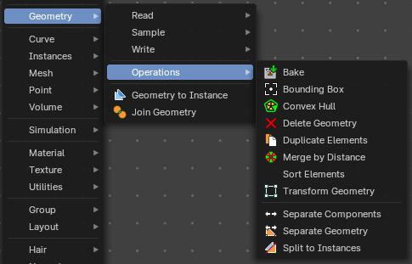
Here you find nodes to modify the geometry.

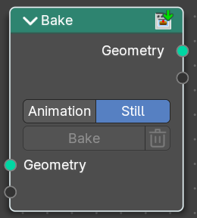
Bake
Allows saving and loading intermediate geometries. This allows you to bake node tree parts to achieve better performance. Or you can bake some data for use with a render engine.

Input

Geometry
Standard geometry input.

Properties

Animation / Still
Bake a animation or a single frame. Note that the bake node does not do automatic caching.

Output

Geometry
Standard geometry output.

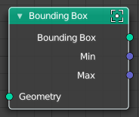
Bounding Box
The Bounding Box geometry node allows you to work with the values of a bounding box.

Inputs

Geometry
Standard geometry input.

Output

Bounding Box
Standard output.

Min
The minimum values of the bounding box.

Max
The maximum values of the bounding box.

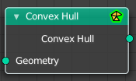
Convex Hull
The node allows you to work with the values of a convex hull of this object.

Inputs

Geometry
Standard geometry input.

Output

Convex Hull
Standard output.

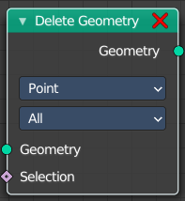
Delete Geometry
The node allows you to work with the values of a convex hull of this object.

Inputs

Geometry
Standard geometry input.

Selection
A selection of the geomerty

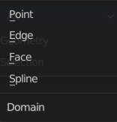
Properties

Domain
What element to delete.


Mode
Delete mode. Names should be self explaining.

Output

Geometry
Standard output.

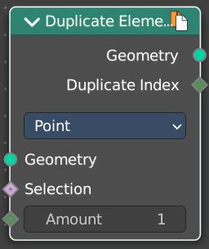
Duplicate Elements
Duplicates a part of a geometry a dynamic number of times.

Inputs

Geometry
Standard geometry input.

Selection
A selection of the geomerty.

Amount
Number of times the geometry should be duplicated.

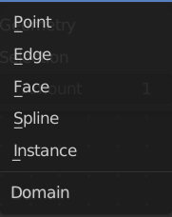
Properties

Domain
What element to duplicate.

Output

Geometry
Standard output.

Duplicate Index
The index of the duplicated elements.

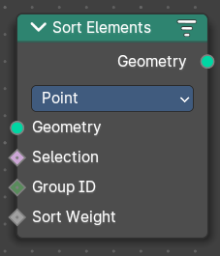
Sort Elements
The Sort Elements node rearranges geometry elements by changing their indices.

Input

Geometry
The input geometry.

Selection
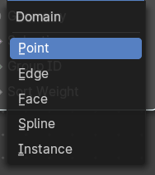
A selection of the input geometry. If left blank, all elements are sorted. Non selected elements will be keep their current indices.

Group ID
Group ID input value. A group is defined as all elements with the same group id. Elements with the same group ID are sorted together. If this is not a field, the node has no affect.

Sort Weight
The sorted values used to do the reordering. If this is not a field, the node has no affect.

Properties

Domain

Point
The fields are evaluated on points, control points, and vertices.

Face
The fields are evaluated on the edges of the mesh component.

Edge
The fields are evaluated on the faces of the mesh component.

Spline
The fields are evaluated on the splines in the curve component.

Instance
The fields are evaluated on the top-level instances. Realized instances are ignored.

Output

Geometry
The output geometry.

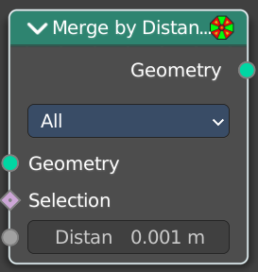
Merge by Distance
Welds the selected geometry below a given distance into one vertice.

Input

Geometry
The input geometry.

Selection
A selection of the input geometry.

Distance
The merge distance. Everything below this distance will be merged into one vertice.

Properties

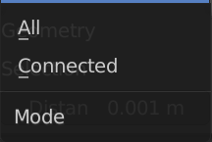
Mode

All
Merges all vertices in reach.

Connected
Merges just vertices that are connected by edges.

Output

Geometry
The output geometry.

Transform Geometry
Move, rotate or scale the geometry. The transformation is applied to the entire geometry, and not per element. For example, you can not rotate individual point cloud points with this node.

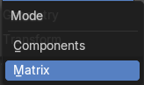
Mode
The transformation mode for the node.

Components
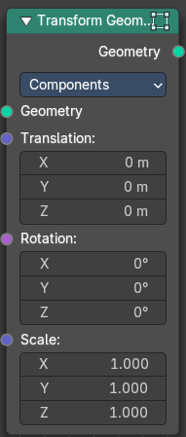
Uses single values and vectors.

Inputs

Geometry
Standard geometry input.

Translation
Translates the geometry in local space of the modified object.

Rotation
Euler rotation in local space.

Scale
Scale to transform the geometries in local space.

Output

Geometry
Standard geometry output.

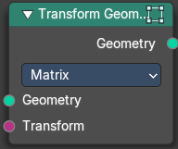
Matrix
Uses a matrix to transform.

Inputs

Geometry
Standard geometry input.

Transform
Transform matrix input

Output

Geometry
Standard geometry output.

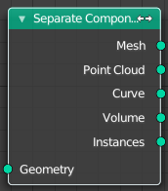
Separate Components
Splits a geometry into its components.

Inputs

Geometry
Geometry input.

Outputs

Mesh
Mesh component of the input geometry.

Point Cloud
Point cloud component of the input geometry.

Curve
Curve component of the input geometry.

Volume
Volume component of the input geometry.
In case that the input contains multiple volume instances, only the first volume component will be calculated.

Instance
The single instances of the geometry.

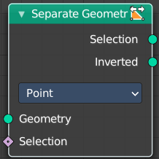
Separate Geometry
Separates a selection of a geometry into its own object.
Tip: when you combine it with the Compare Floats nodem then you get a more precise control of which parts are separated to a given output geometry.

Inputs

Geometry
Geometry input.

Selection
Selection input.

Properties

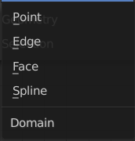
Domain
What kind of geometry to separate.
Note that when selecting a domain that doesn’t modify all components, the unmodified components will appear in both outputs.

Outputs

Selection
Separated selection.

Inverted
The inverted separated selection.

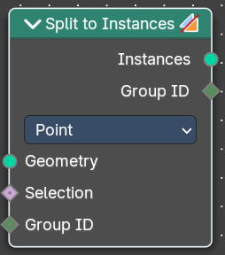
Split to Instances
This node allows splitting up a geometry into groups. A group is defined as all elements with the same group id.
The node supports meshes, curves, point clouds and instances. Note that it only works on the top-level geometry. It does not go into nested instances because it also generates new instances.

Inputs

Geometry
Geometry input.

Selection
Selection input.

Group ID
Group ID input value.

Properties

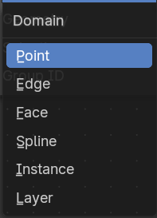
Domain
What kind of geometry to separate.
Note that when selecting a domain that doesn’t modify all components, the unmodified components will appear in both outputs.

Outputs

Instances
Instances output. An Instance per group.

Group ID
Group ID output value.

